Lab 18: Adding documents & Queries in Mongo

LIS464-Applied Database Design

Information School, University of Wisconsin-Madison

# **Task 1: Practice uploading document to MongoDB Compass:**

This lab makes use of the Mongo compass video at: <https://www.youtube.com/watch?v=YBOiX8DwinE>

**Step1: Create a database called people, and create a collection called people**

See Compass video (7:00 minute mark) example for store database. But change yours to people.

<https://www.youtube.com/watch?v=YBOiX8DwinE>

**Step2 : Upload this JSON document into the People.people database.**

How? Click insert document, and copy the text below, or import the .json file provided on the assignment Canvas page.

Need an example? Follow the example on the Compass video (see 7:00 minute mark)

**Click insert document, and copy the file below in insert into the database!**

[

{ "user_id": "Eoin", "age": 29, "Status": "A","Country": "USA"},

{ "user_id": "Daniel", "age": 25, "Status": "A", "Country": "USA" },

{ "user_id": "Max", "age": 35, "Status": "B", "Country": "Canada" },

{ "user_id": "Jessie", "age": 23, "Status": "C", "Country": "Japan" },

{ "user_id": "Cathy", "age": 49, "Status": "A","Country": "USA"},

{ "user_id": "Nick", "age": 34, "Status": "C", "Country": "Canada" },

{ "user_id": "Chris", "age": 56, "Status": "B", "Country": "Mexico" },

{ "user_id": "Jay", "age": 23, "Status": "D" }

]

**Task 2: Queries in MongoDB Compass**

**Get these simple queries from this document:**

**Your answer should consist of screenshot(s) showing both the code and the output of each question!**

**Q1:Find the document with status equal to “D”.**

**Q2:Find the documents with status equal to ‘’A’’ or “D”**

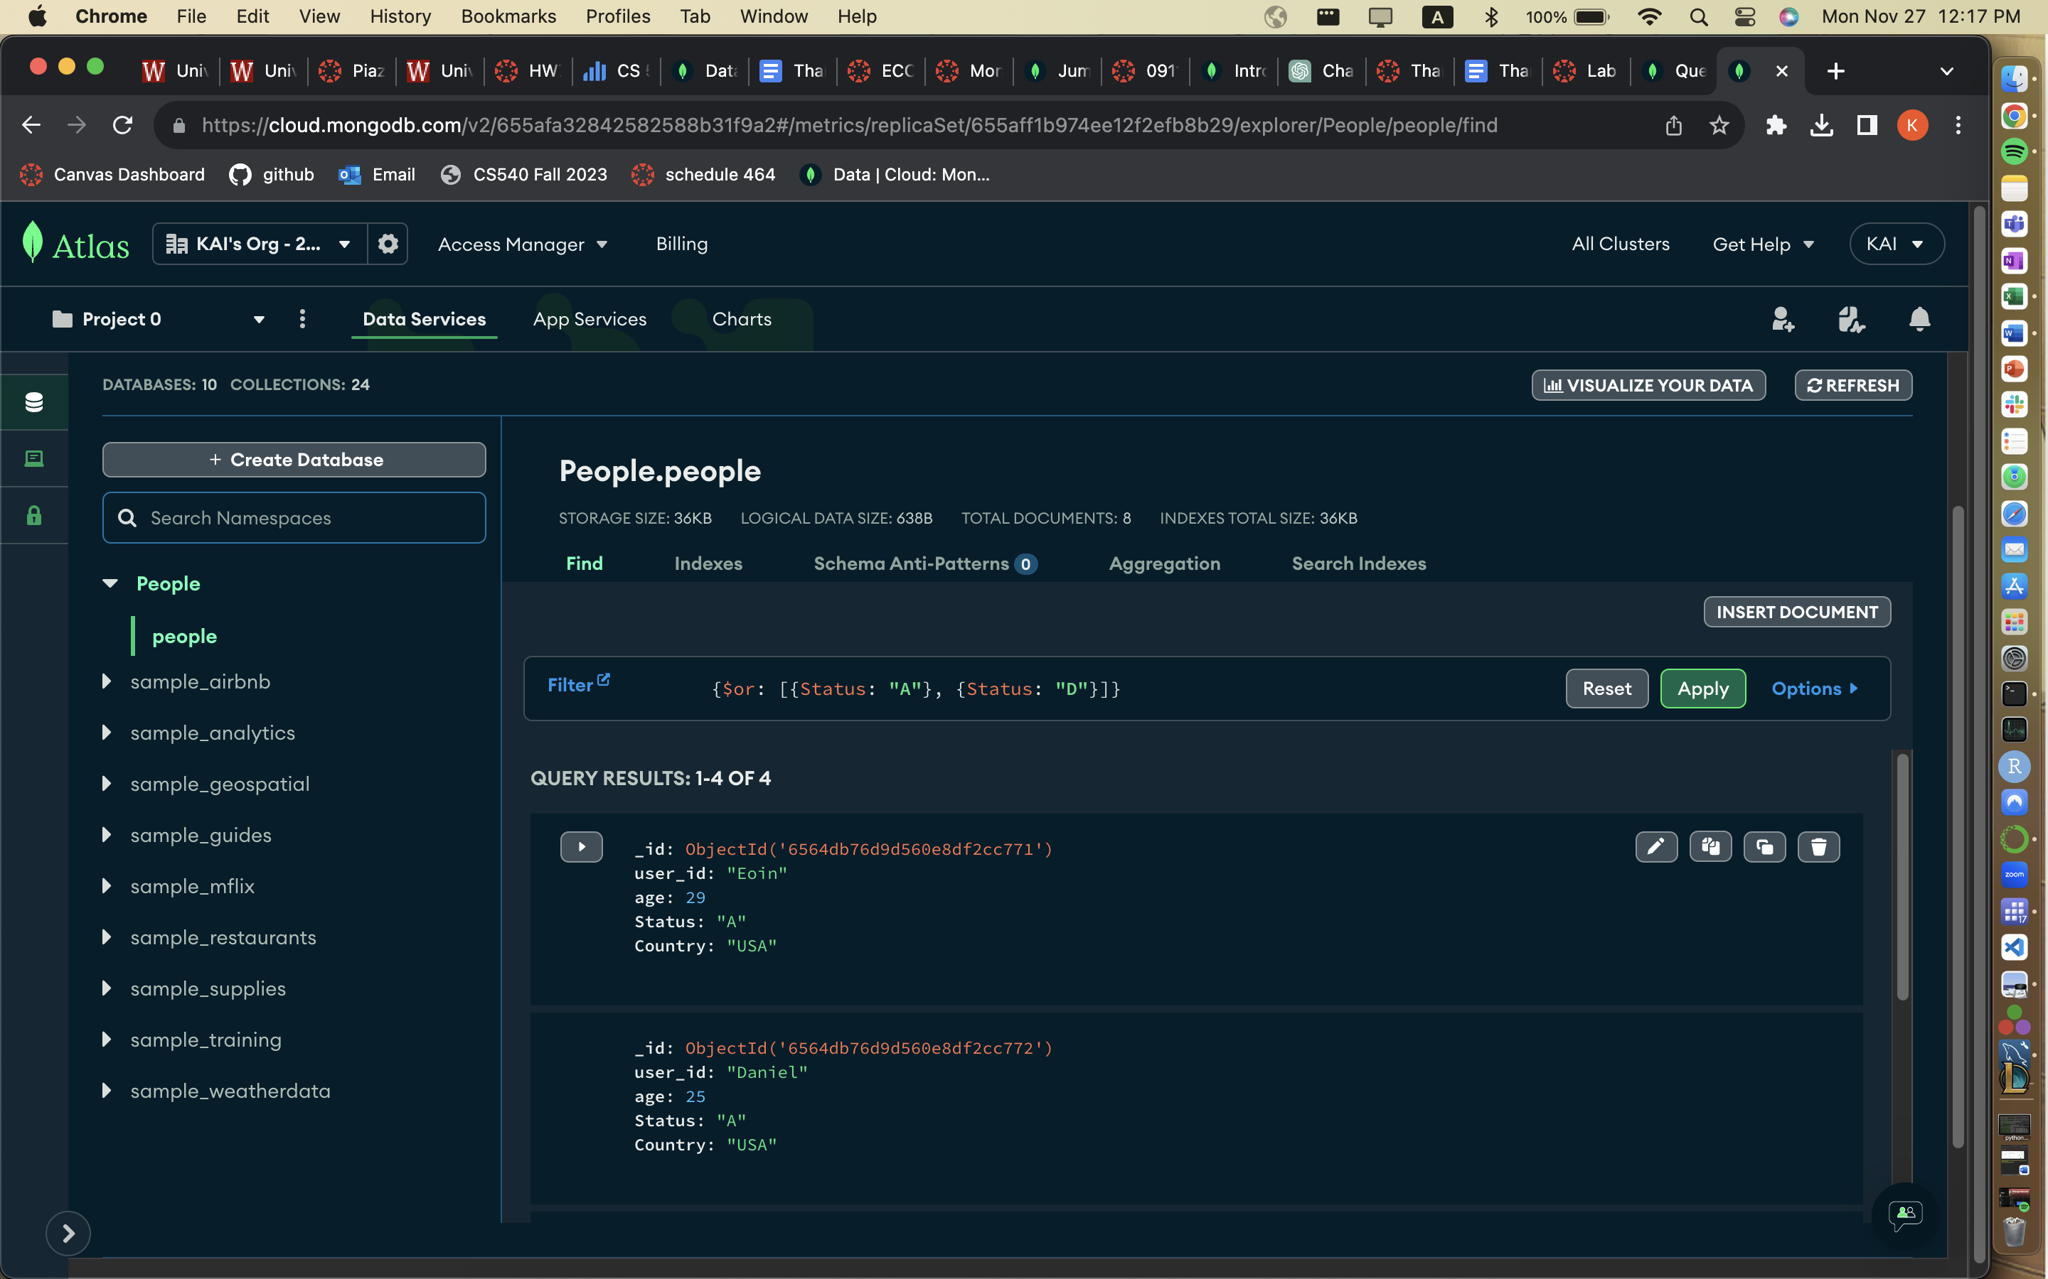

**Q3:Show the first two documents**

**Screen of the output:**

**Q4:Find the documents with ages greater than 30**

**Q5:Find the country = USA and age <30**

**1-1.Code: {Country: “USA”, age: {$lt: 30}}**

**Q6:Find the age >30 and age <50**

**2-1.Code: {age: {$gt: 30, $lt: 50}}**

**Q7:Find the status= A and age >25 and age <30**

**3-1.Code: {Status: "A", age: {$gt: 25, $lt:30}}**

